Contact: Jon Magnusson  Phone +46 70 3018941  E-mail jon.magnusson@hotmail.se | Fogdevägen 47  12841 Bagarmossen  Sweden
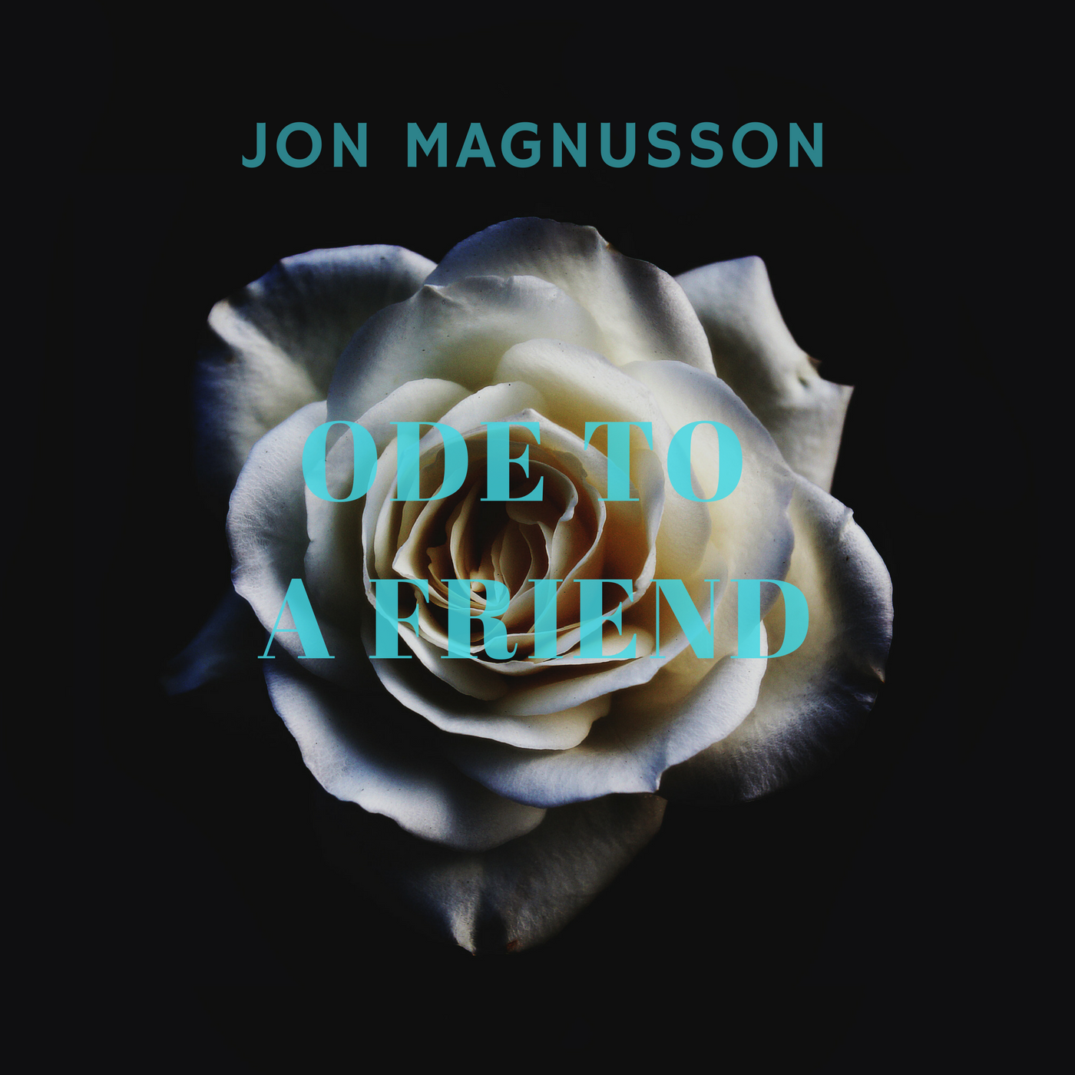
Press Release

Jon Magnusson’s new single “Ode to a Friend” is out!
Stockholm, Sweden, 19 March 2017
If Jon Magnusson’s latest song “Your Dreams” were upbeat and happy, “Ode to a Friend” is quite the opposite. Inspired by folk acts like The National, Iron & Wine and Elliot Smith, this epic tune brings up strong emotions since it’s a tribute to a friend of the artist, who was taken away way too young. At the same time it’s a bittersweet celebration to life and friendship.

Jon Magnusson’s work is currently in rotation on Radio Kaos Maribou and Somer Valley FM, with other like-minded stations certain to follow suit. “Ode to a Friend” scored an average of 7.1 points (out of 10) in 50 crowd reviews at ReverbNation where a score above 7.0 indicates a high quality track.

“I really like the piano interlude and then how all the sounds come together and mix well. The singer's voice is mellow and very pleasant to listen to.” – ReverbNation crowd review, 19 March 2017

“I loved this song” – Laure SZY, Staff Member @ Radio Kaos Caribou

Jon Magnusson is a songwriter/musician/producer/audio engineer from Stockholm, the picturesque capital of Sweden. The music he writes and plays is often plain folk with a touch of rock and punk influences and an occasional jazzy beat thrown in to keep listeners on their toes. Most of all, it’s his thoughts and feelings put to lyrics and chords that are encouraging people to hear more of his repertoire that’s now being shared with the world- enjoy!

“Ode to a Friend” is the second single from Jon Magnusson’s new EP, releasing spring 2017. All his music can be found at jonmagnusson.se, Spotify, Apple Music and other services.

For more information please contact Jon Magnusson on +46703018941 or jon.magnusson@hotmail.se.

