Contact: Jon Magnusson  Phone +46 70 3018941  E-mail jon.magnusson@hotmail.se | Fogdevägen 47  12841 Bagarmossen  Sweden
Press Release

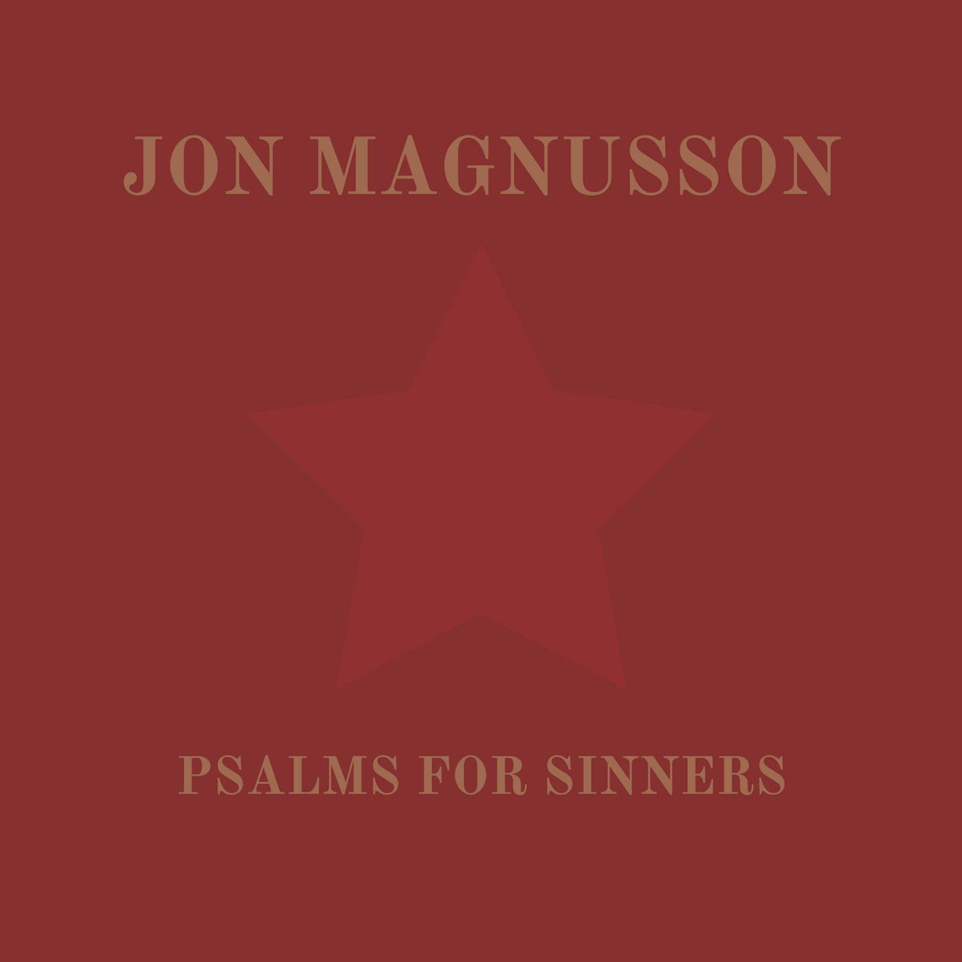
Jon Magnusson’s new EP “Psalms for Sinners” is out!
Stockholm, Sweden, 8 April 2017
The intro tune “Visa från Utanmyra” is a jazzy interpretation of an old Swedish folk song from the early 1900’s. You can almost smell the forest and feel the wind on your face listening to this instrumental jewel.

“Ode to a friend” brings up strong emotions since it’s a tribute to a friend of the artist, who was taken away way too young. At the same time it’s a bittersweet celebration to life and friendship.

The title track “Psalms for Sinners” paints the picture of young people rumbling around the city streets intoxicated by love. An upbeat indie folk tune that surely will make you move your feet.

The EP rounds up with maybe the strongest track “Your Dreams”. A catchy indie rock tune with strong folk influences. Written about struggle; be it personal, political or otherwise, a theme we’re all familiar with in some variety and he’s left room for the listener to decide how it applies to them.

This EP shows the width of Jon Magnusson musical influences and still it creates a whole of strong melodies, authenticity and a positive outlook on life blended with strong emotions.

Jon Magnusson’s work is currently in rotation on Radio Kaos Maribou, Somer Valley FM, Lonely Oak Radio, Svenska Näradiolistan, Indie Rage Radio and other like-minded stations.

“Amazing EP. It eases you in with a beautiful, almost medieval opener and then “Ode To A Friend” is an outstanding and very touching tribute that almost had me in tears. “Psalm For Sinners” is probably the weakest track for me and what I would class as a “B” side however this no way detracts from the stunning release. “Your Dreams” is up there with the best indie pop music and it will be stuck in your head all day long. The production is really quite special and you can hear that a lot of thought and love has gone into the creation of this EP. Being of Swedish tongue Jon’s voice also makes this unmistakably him and it adds another element that seems to work really well. Give it a listen. You won’t be disappointed.” Juxta John – UK artist and founder of Atom Collector Records.

Jon Magnusson is a songwriter/musician/producer/audio engineer from Stockholm, the picturesque capital of Sweden. The music he writes and plays is often plain folk with a touch of rock and punk influences and an occasional jazzy beat thrown in to keep listeners on their toes. Most of all, it’s his thoughts and feelings put to lyrics and chords that are encouraging people to hear more of his repertoire that’s now being shared with the world- enjoy!

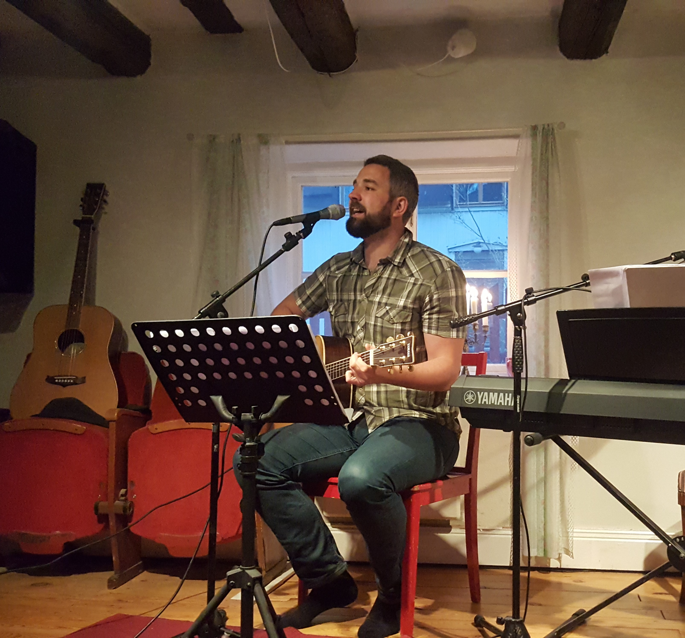

Homepage: http://www.jonmagnusson.se
Facebook: https://www.facebook.com/jon.magnusson3
Spotify: https://open.spotify.com/artist/5K8khjFCd5ImBxNFzYusLc
SoundCloud: https://soundcloud.com/beljon86
Twitter: https://twitter.com/jonmagnussonof
YouTube: https://www.youtube.com/channel/UCmEV76SiJz2OjHOZqnYDDEQ

